

**3T Member Staging**

# Table of **Contents**

Table of Contents 1

Document Information and Key 2

Flowchart 3

Purpose 4

Stage 1: Member sends 3T File to FTP 5

ETL Process Overview 5

FTP Walkthrough 5

Stage 2: 3T File Resides in FTP 7

FTP Address Location 7

Data Submission File Integrity 8

Stage 3: Generate and Distribute Data Quality Reports 8

What are Data Quality Reports? 8

3T Queries for Data Load Check 10

Stage 4: Member Contact 11

Preparing Error Records for the Member 11

Email Templates for Member Contact 12

Ex.1: When first introducing yourself to a member 12

Ex.2: When explaining the DQR Process 13

Ex.3: When following up for a DQR 13

Communication Concerns 14

Stage 5: Member Sign Off and Discuss with Member on Fixes 14

Stage 6: Finalize with cleansing, importing, merging data 14

Signoff Process w/ SQL 14

Signoff Example: Baptist East 15

# Document Information and Key

Yellow Highlight: Review with team for questions

Green Highlight: Accepted information

# Flowchart

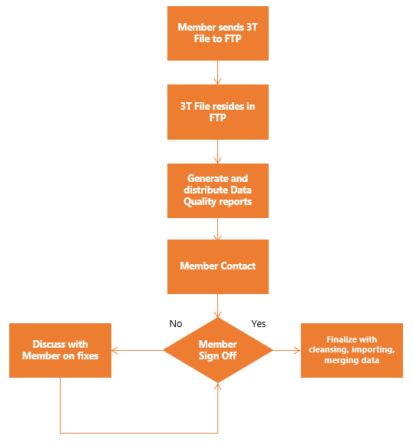

# Purpose

The purpose of this document is to illustrate how the 3T Member Staging process works within the current infrastructure, and how it can be used to assist members with delivering their data to our internal network. This process is precursory in the 3T Staging Process. This document describes how to communicate with members and the step-by-step process in ensuring data submissions are received, cleansed based on member specifications, member sign-off, and loading the finalized data.

# Stage 1: Member sends 3T File to FTP

## ETL Process Overview

To better understand the DQR process, we need to recognize that this process is an ETL or extract, transform, load procedure. Our members send in their facility data, known as the data submission; the goal is to enforce/enact data quality standards, and provide our members quality reporting. When members send in a data submission, it comes in the form of two files, the 3000 file (3T) and the Physician Roster (PR) files. The way we receive these files is by an FTP server within our system and the members are given credentials to access and send files to their designated “FTP_VSE” folder.

## FTP Walkthrough

To better understand what sending files might look like on the member side, here is a tutorial on accessing the FTP with FileZilla.

**\*Please note that not all members use FileZilla, and their process to accessing the FTP may differ. This is meant to be a representation of similar principles when using our FTP.**

1) First, you will need the credentials to the member’s FTP. Use this path address:

\\sql02\FTP3000\Member FTP Credentials

2) Click on the folder of your designated member and proceed to open the Word document inside. Each of these files are protected by a password, make sure to contact the BI team before trying to access these files, they will provide you the credentials. **DO NOT** **disseminate or give out any of these passwords.**

The document should look something like this:

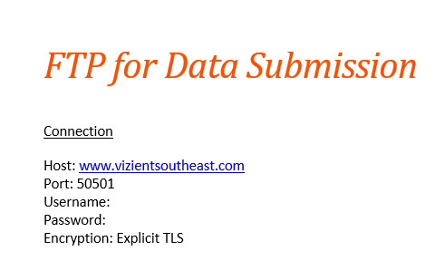

For purposes of this walkthrough, we will be using Baptist Health as per example.

3) Open FileZilla and select Site Manager.

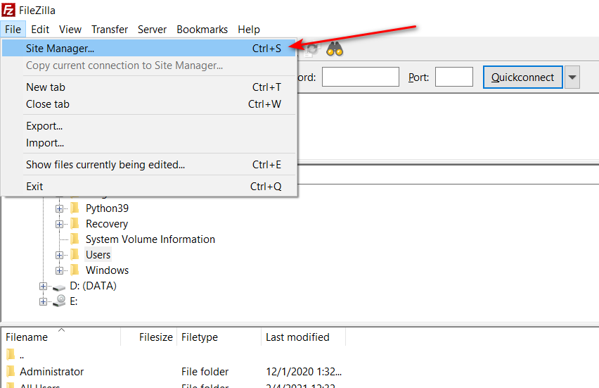

4) Create a folder to store the member sites.

5) Within the folder, select the “New Site” button. This will create a connection to the FTP. Use the credentials from the Word document to fill in the rest of the textboxes, as per example:

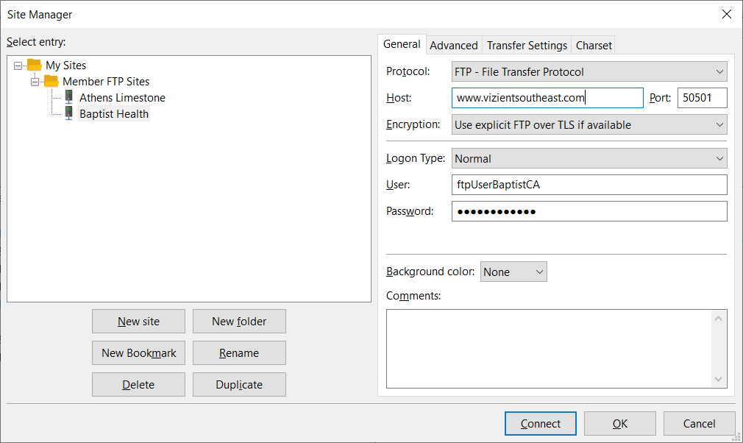

If the login is successful, you should be able to see the FTP folder load with the member’s files.

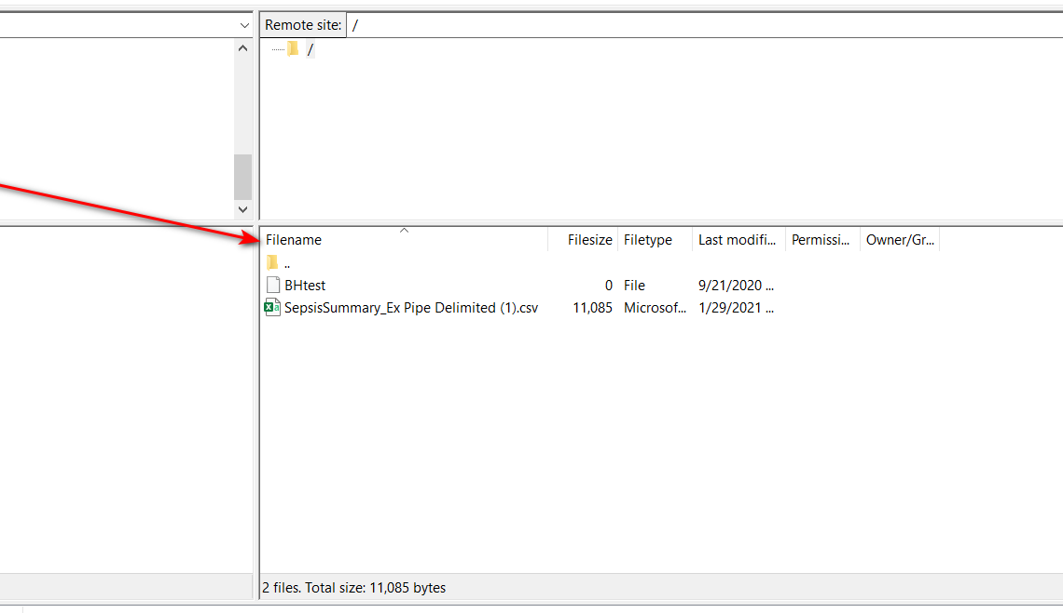

Make time to create sites for all the members, as you might be responsible for assisting them if there are any outstanding issues in the FTP. This is the quickest way to troubleshoot and connection issues, as the process for logging into the FTP for both the members and this walkthrough are virtually the same.

# Stage 2: 3T File Resides in FTP

## FTP Address Location

To find the data submissions from our members, use this path address to access the FTP folder:

\\SQL02\c$\inetpub\ftproot\LocalUser

Within this folder, you will notice the varying names. These acronyms represent the hospitals and their HCO Codes, for example:

Ex.1) **ftpUserALKA2** = AL 🡪 Athens Limestone

KA2 🡪 HCO_CODE

Ex.2) **ftpUserHMEA** = HM 🡪 Halifax Medical Center

EA 🡪 HCO_CODE

## Data Submission File Integrity

When accessing a folder, once a member sends in their data submission, check for file integrity. This can include:

- The file name, which should follow this format:

- HOSPITALNAME_StartDate_EndDate_3T

- HOSPITALNAME_StartDate_EndDate_PR

- Confirm that the end of the file name does **NOT** include any extensions, and if there are any, do make sure to delete .

- Ex. HOSPITALNAME_StartDate_EndDate_3T.**txt**

# Stage 3: Generate and Distribute Data Quality Reports

## What are Data Quality Reports?

After reviewing the files sent by our members, it is time to create a Data Quality Report, or DQR for short. The purpose of these reports is to quickly view any errors that **PORTAL_ENGINE** caught when loading the 3T file into the tables; the 3T files are loaded into the **3T_Import_Staging** and **3T_Import_Staging_Error** tables. When this happens, these reports are automatically generated on sql02. These reports are necessary in the staging process, as it will allow members to have an overview of the errors in their data before we release it into the portal.

To access these reports, use this link: <https://www.vizientsoutheast.com:4433/portal/Intranet/3T_Import_Error_Report.aspx>

If you have trouble accessing this link, access VSE’s Intranet and click on the link shown below: <https://www.vizientsoutheast.com:4433/portal/Intranet/IntranetDefault.aspx>

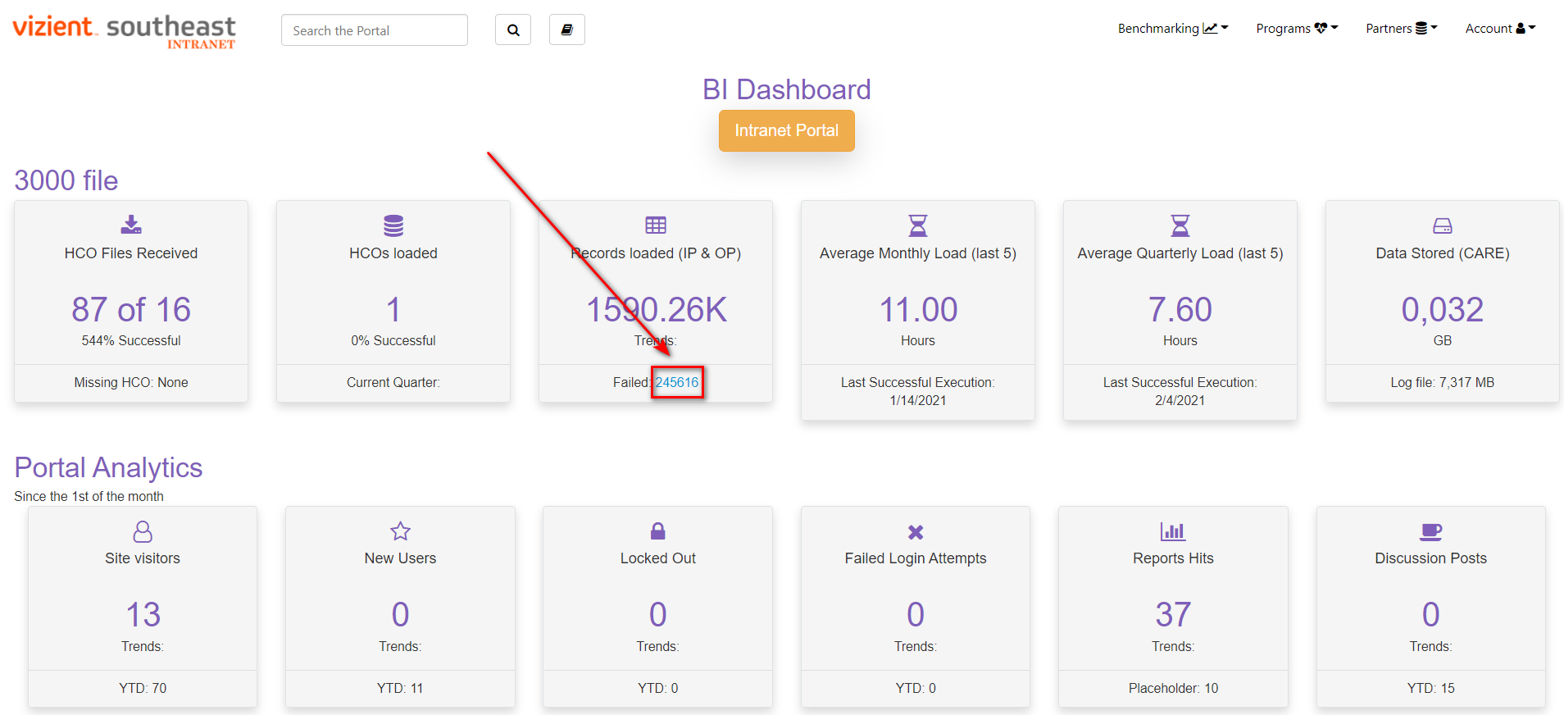

You will be brought to a site titled “File Submission Report”. Here, you can select various 3T FTP files by each respective member. If you wish to access a particular report, here is how. In this example, we want to find the errors for Athens Limestone for the month of September.

1) To view any DQR, just select any link in the batchID column:

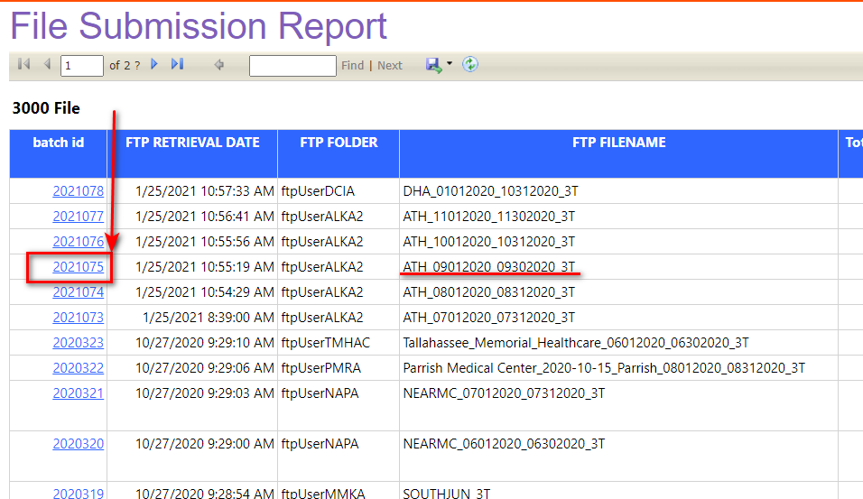

2) To export a DQR, you can select the save drop-down button, and select any of the formats. You can also use any screen capture program with a scrolling feature like FastStone Capture.

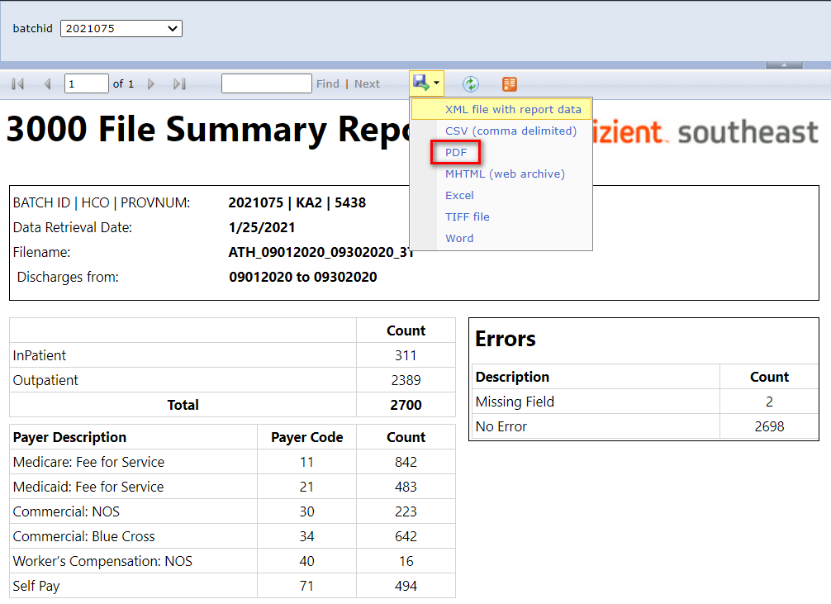

## 3T Queries for Data Load Check

However, it is always important to check the database in case the reports either did not generate correctly or if a batch has not been loaded yet. If you go into SQL Server in **PORTAL_ENGINE**, you can run the query below to double check if the member’s data was loaded. This query will show you the batches that have been loaded in the desired table on **HCO_CODE**/member by all date ranges. You can also change the table from **3T_Import_Staging** to either **3T_Import_Staging_Error** or **3T_Import**, and the query will run the same way.

**3T_Import_Staging**

select hco_code, BATCHID, i.provnum, min(disdate) as minDisDate, max(disdate) as maxDisDate from [3T_Import_Staging] as i

join global.dbo.refhco as ref

on i.PROVNUM = ref.PROVNUM

where HCO_CODE = 'ac1'

group by i.provnum, batchid, hco_code

order by minDisDate

**3T_Import_Staging_Error**

select hco_code, BATCHID, i.provnum, min(disdate) as minDisDate, max(disdate) as maxDisDate from [3T_Import_Staging_Error] as i

join global.dbo.refhco as ref

on i.PROVNUM = ref.PROVNUM

where HCO_CODE = 'ac1'

group by i.provnum, batchid, hco_code

order by minDisDate

**3T_Import**

select hco_code, BATCHID, i.provnum, min(disdate) as minDisDate, max(disdate) as maxDisDate from [3T_Import] as i

join global.dbo.refhco as ref

on i.PROVNUM = ref.PROVNUM

where HCO_CODE = 'ac1'

group by i.provnum, batchid, hco_code

order by minDisDate

# Stage 4: Member Contact

## Preparing Error Records for the Member

Before any DQR email is sent out, make sure to prepare the member’s error record. The DQRs provides a general overview of the errors currently presiding within the database, the error records are the specific records that are either missing values within their respective column or an incorrect datatype. From **3T_Import_Staging_Error**, you will need to copy each batch into an Excel worksheet; this will provide the member a way to communicate which records they can either correct or delete.

To find these error records, go to the [3T_Import_Error_Report](https://www.vizientsoutheast.com:4433/portal/Intranet/3T_Import_Error_Report.aspx) page. Look for the batch, then select the “Get Code” link on the far right column:

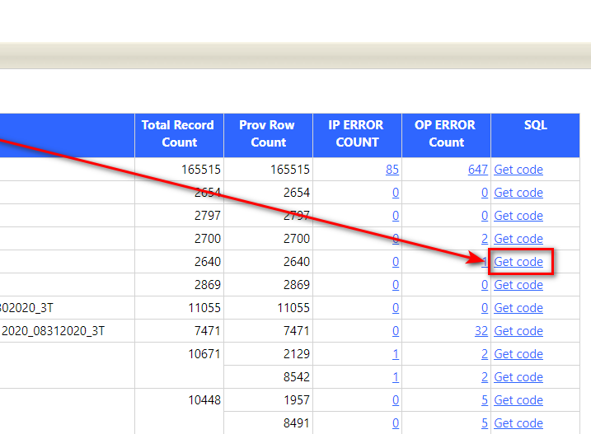

You will want to copy the query with the comment “Get records to share with member using FTP”. Once you run the query, you will need to copy all the records, then paste the records into the template excel worksheet in the \\SQL02\f$\Import\b\3000 File path.

Rename the document by this format: **FTPUSER_BATCHID_MONTHYEAR**

Ex. For Tallahasse – TMHAC_2021219_102020

When you have finished putting together the worksheet, place the member’s error records into their FTP folder, that way they can view the worksheet as soon as they receive your DQR email.

## Email Templates for Member Contact

Once you have gathered all the DQRs for the members you wish to send, it is time to reach out. This section will consist of varying examples to help structure your email when communicating with members. Please acknowledge that not all examples will fit your circumstance and is best to communicate with your team if any issues or concerns may arise.

### Ex.1: When first introducing yourself to a member

Good Morning/Afternoon [Member First Name],

My name is **BLANK** from Vizient Southeast, and I am reaching out to all our members to introduce myself as the new contact for data submissions, data quality reports, and cube support. If there are any questions or concerns you may have regarding the monthly submission process, please feel free to contact me at any time.

I will be following up soon with a sample Data Quality Report for your review.

Thank you for your time, and I look forward to working with you!

### Ex.2: When explaining the DQR Process

Hello BLANK,

I wanted to follow up with you about the Data Quality Reports (DQR) related to your data submissions from Vizient Southeast. The purpose of the DQR is to provide an analysis on how well your data has translated into our system through error reporting and record confirmation. The goal is to offer members an opportunity to reassess their data before it is released to you for clinical and operational benchmarking on our Portal/Cube. I have attached your DQR for your review and at the time this email is sent, you can review the errors on your FTP folder.  Options for correcting data errors include:

* Fixing the records in-house with information provided by Vizient Southeast member
* Replacement of data with resubmitted batch file(s)
* Deleting unnecessary and/or redundant data

If you have any question about the process, please feel free to call or email me anytime. We’d like to make this new process as streamlined as possible.

Thank you for your consideration.

### Ex.3: When following up for a DQR

Hello Blank,

I have attached your DQR for your review and at the time this email is sent, you can review the errors on your FTP folder; it will come in the form of an Excel worksheet. For correcting these errors, you can either:

• Fix/fill in the errors with the correct information

• Deleting unnecessary and/or redundant data

• Replace the data with resubmitted batch file(s)

While in the worksheet, if you have trouble finding the error, you can go to the furthest column on the right, and the error’s record will be specified in the ErrorDescription column.

If you have any questions, do feel free to contact me anytime.

## Communication Concerns

Do understand that patience is required with the members, some members are more consistent than others. If you do have trouble getting in contact with any member, be sure to carbon copy/CC our team members, as this will help everyone involved with bridging the communication gap and will allow our team members to step in when necessary.

# Stage 5: Member Sign Off and Discuss with Member on Fixes

In this stage, you will communicate with the member on any changes they would like made to their data. In some instances, you may find yourself with members who have very few errors and may task you with deleting only a handful of dismissible records. These situations are easily met with the least resistance, as you can hand select batchIDs within SQL.

On the other hand, you may find yourself in a situation where an entire data submission is a complete wash, one with tens of thousands of records that cannot be used. When dealing with these situations, where there are too many records, you may find it easier for both parties to agree on a brand-new submission. Keep the BI team in the loop, as they will be the ones to be uploading the new submission into the database.

Again, all circumstances are not the same, and would implore you to ask your team or the BI team when necessary.

# Stage 6: Finalize with cleansing, importing, merging data

This portion is the most important stage, as you may be responsible for cleaning the data yourself. This process will explain the technicality of how the data is moved, cleaned, and finalized.

## Signoff Process w/ SQL

If you recall from the Member contact stage, you will similarly need to go into the “Get Code” section of the File Submission Report. Here is where you have access to the necessary queries to move the data from **3T_Import_Staging** and **3T_Import**, into **3T_Import_Awaiting_Signoff**.

To better understand this process, below is a diagram representing a simplified version of how the Signoff process works:

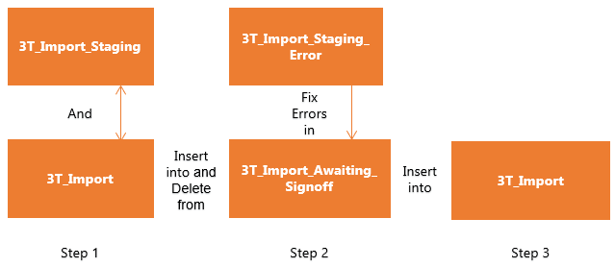

The end goal is to clean up the data in a way that will safely arrive back in **3T_Import**. It starts in Step 1, where both **3T_Import_Staging** and **3T_Import** are inserted into **3T_Import_Awaiting_Signoff**. The errors will be removed using the **3T_Import_Staging_Error** table. Once those records are cleaned up, they can be removed from both previous tables, and inserted back into **3T_Import** as it is the final stage before being pushed downstream for reporting. Usually, you want to keep the records in **3T_Import_Awaiting_Signoff**, just in case it does not load properly and to prevent accidentally deleting the whole batch from all tables.

## Signoff Example: Baptist East

For this example, we will use December 2020’s batch for Baptist East. Select “Get Code” to open the queries.

1) Copy/ paste the first query labeled “Insert records into Signoff table”, make sure the database is set to **PORTAL_ENGINE**.

--Insert records into Signoff table:

Insert into [3t_Import_Awaiting_Signoff]

select *,'Check in Error table for details' as ErrorDescription from [3T_Import_Staging]

where batchid = '2021231'

and provnum = '5468'

This will populate the **3T_Import_Awaiting_Signoff**, with all the records from **3T_Import**_**Staging**.

2) Run the “Get records to share with member using FTP” query to match the errors up against **3T_Import_Awaiting_Signoff**.

--Get records to share with member using FTP:

Select * from [3t_Import_Staging_Error]

where batchid = '2021231'

and provnum = '5468'

3) From here, clean the errors in **3T_Import_Awaiting_Signoff**.

For this example, there are only 3 unique error records to be deleted from this batch:

DELETE FROM [3T_Import_Awaiting_Signoff]

WHERE batchid = '2021231'

and provnum = '5468'

and ID IN ('1672805', '1677822', '1681331')

4) This batch is now cleaned up, you can delete the records from both **3T_Import_Staging** and **3T_Import**:

--Delete records

--from Staging:

Delete from [3T_Import_Staging]

where batchid = '2021231'

and provnum = '5468'

--from Import:

Delete from [3T_Import]

where batchid = '2021231'

and provnum = '5468'

Once the records are completely deleted from both tables, reload the records back into **3T_Import**. At the bottom of the page, you will notice the deletion query for **3T_Import_Awaiting_Signoff** table, please **DO NOT** run this query until you have finished with loading it back into **3T_Import**. The signoff table is meant to be a backup table, and in most cases its best to keep it the untouched until the next monthly batch of DQRs. That way you can clear out unnecessary records and replace it with the new batches.

Make sure to let the BI team know when you have finished with a member’s batch, so they can run the MSDRG Grouper on the load.

- Need information again on what the MSDRG is

Lastly, always follow up with the member once the signoff clean up is complete.